**B.P.H.E Society’s Ahmednagar College**



**DEPARTMENT OF COMPUTER SCIENCE**

A Project Report on

“Hotel Management System”

*Submitted in partial fulfilment of the requirement of degree*

**BACHELOR OF COMPUTER APPLICATION**

**-: Submitted By :-**

**Mr. Suraj Aghav**

**University Of Pune, Pune**

**Academic Year : 2023 – 2024**

**Acknowledgment**

I wish to express my sincere gratitude to God for his protection, providence, guidance and above all, for sustaining us.

I would like to express our special thanks of gratitude to our professor ‘**Shital Awate mam’**as well as our H.O.D ‘**Razak Sayyed sir**’ who gave me the golden opportunity to do this wonderful **project** on the topic **‘Hotel Management System’** , which also helped me in doing a lot of Research and gaining some precious

**Index**

* **Abstract**
* **Introduction of Project**
* **Existing System**
* **Problem Definition**
* **Objectives of the Project**
* **Feasibility Study**
* **Platform [ H/w and S/w Requirement]**
* **Fact Finding Techniques**
* **Database Design**
* **Entity Relationship Diagram**
* **UML Diagram**
* **Input Output Screens**
* **Limitations and Drawback**
* **Future Enhancements**
* **References and Bibliography**
* **Conclusion**

**Abstract**

In my project “**Hotel Management System**” I have tried to show how the data/information in hotels is managed. This is just an overview of management in hotels. It manages and maintains the records of customers, rooms, employees and drivers in the hotel. The project is aimed to maintain the day-to-day state of admission/vacation of Residents, List of employees, room details etc. Main objective of this project is to provide solution for hotel to manage most there work using computerized process. This software application will help admin to handle customer information, room allocation details, Payment details etc.

The rooms have different categories like single bed, double bed etc. so their charges and records will be maintained accordingly.

This software has been made in a user friendly interface, so that anyone can add, delete, update the entries and handle all the transactions easily. As a security I have provided Admin username and Password.

**Introduction Of Project**

The project, Hotel Management System is a desktop-based application that allows the hotel manager to handle all hotel activities online. Interactive GUI and the ability to manage various rooms, employees, drivers and customers make this system very flexible and convenient. The hotel manager is a very busy person and does not have the time to sit and manage the entire activities manually on paper. This application gives him the power and flexibility to manage the entire system from a single online system. Hotel management project provides room booking, staff management and other necessary hotel management features. The system allows the manager to post available rooms in the system.

The Purpose of the whole process is to ease the daily or regular activities of the Hotel Management into an automatic computerized retrievable process. The daily activities includes the Room activities, Entering details of the new customer check in, To allocate a room as per the customer need and interest, Recording the checkout time and details, Releasing or Empty of room and to record the process in a computer system for future.

The application of the Hotel Management System bears the following functions to use by the Administrator:

* Add a new Room
* Add an Employee
* Add a new Customer
* Add a new Driver
* Check room status
* Check all employees’ details
* Check all Customers’ details
* Update room status
* Update check status
* Check IN and Check OUT

**Existing System**

In the existing manual system a lot of time is spent in communicating the information across different branches. There is a need for an automated system, which has some centralized control over the entire process. Conventional System makes use of huge amounts of paper for recording transactions. All the Hotel records are to be maintained for the details of each customer, Fee details, Room Allocation etc.

**Disadvantages:**

* Time consuming
* Inaccuracy of data

**Problem Defination**

* The Present System ( i.e. manual system means writing on Paper and store all record in a Register) doesn’t consist of proper maintenance of data as well as finding of data or retrival of data.
* It suffers from difficulties to maintain the daily transactions like Customer check in or check out and pending amount, etc.
* It requires lot of time and money on maintaining that type of data (means, data in written format ).

**OBJECTIVE**

### The objective of the Hotel Management System is to develop a project which maintains booking of rooms, providing drivers, etc. It is a windows based application to be implemented in Java

The Purpose of the whole process is to ease the daily or regular activities of the Hotel Management into an automatic computerized retrievable process. The daily activities includes the Room activities, Entering details of the new customer check in, To allocate a room as per the customer need and interest, Recording the checkout time and details, Releasing or Empty of room and to record the process in a computer system for future.

Main objective of this project is to provide a solution for hotels to manage most their work using computerized processes. This software application will help admin to handle customer information, room allocation details, Payment details etc.

* Keeping records of admission of customers.
* Facilities provided by hotels are fully utilized in an effective and efficient manner.

**Feasibility Study**

To analyze whether the software will meet organizational requirements Feasibility isdefined as the practical extent to which a project can be performed successfully. Toevaluate feasibility, a feasibility study is performed.

To determine whether the software can be implemented using the current technology and within the specified budget and schedule A feasibility study is a preliminary investigation of a proposed system to decide whether the system can run smoothly with the organization.

To determine whether the software can be integrated with other existing software.benefits that are expected and to decide will the organization go for it.

**Platform Requirement**

Software Requirements

* + Operating System Windows 10
  + Front End Java, NetBeans
  + Back End MySQL

Hardware Requirements

* + Desktop PC or a Laptop
  + Printer
  + Operating System – Windows 10
  + Intel® CoreTM i3-6006U CPU @ 2.00GHz
  + 4.00 GB RAM
  + 64-bit operating system, x64 based processor
  + 1024 x 768 monitor resolution
  + Keyboard and Mouse

**FACT FINDING TECHNIQUES**

To study any system the analyst needs to do collect facts and all relevant information, the facts when expressed in quantitative form are termed as data. The success of any project is depended upon the accuracy of available data.

Accurate information can be collected with help of certain methods/ techniques. These specific methods for finding information of the system are termed as fact finding techniques.

Interview, Questionnaire, Record View and Observations are the different fact-finding techniques used by the analyst. The analyst may use more than one technique for Investigation.

**ER Diagram**

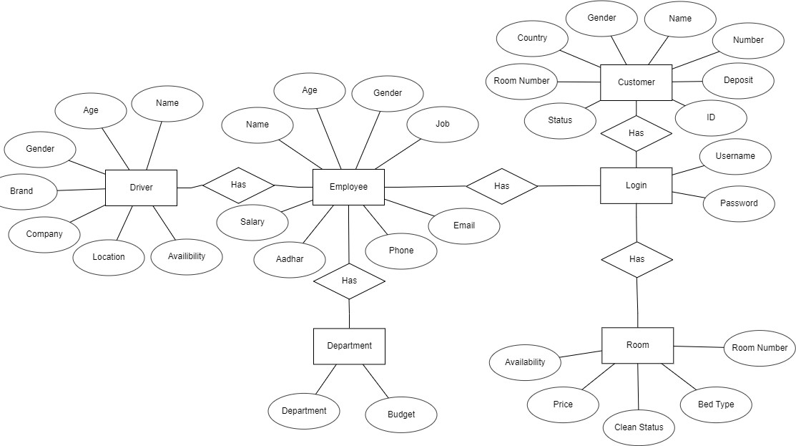

**Database Design**

1. Customer

|  |  |  |
| --- | --- | --- |
| **Field** | **Datatype** | **Constraint** |
| id | Varchar(30) | NN |
| number | Numeric(30) | PK |
| name | Varchar(30) | NN |
| gender | Varchar(30) | NN |
| country | Varchar(30) | NN |
| Room number | Numeric(30) | NN |
| Status | Varchar(30) | NN |
| Deposit | Numeric(30) | NN |

1. Room

|  |  |  |
| --- | --- | --- |
| **Field** | **Datatype** | **Constraint** |
| Room_number | Numeric(30) | PK |
| Availability | Varchar(30) | NN |
| Clean status | Varchar(30) | NN |
| Price | Number(30) | NN |
| BedType | Varchar(30) | NN |

3.Employee

|  |  |  |
| --- | --- | --- |
| **Field** | **DataType** | **Constraint** |
| Name | Varchar(30) | NN |
| Age | Numeric(30) | NN |
| Gender | Varchar(30) | NN |
| Job | Varchar(30) | NN |
| Salary | Number(30) | NN |
| Phone | Number(30) | NN |
| Adhar | Number(30) | PK |
| Email | Varchar(30) | NN |

4.Driver

|  |  |  |
| --- | --- | --- |
| **Field** | **DataType** | **Constraint** |
| Name | Varchar(30) | NN |
| Age | Numeric(30) | NN |
| Gender | Varchar(30) | NN |
| Company | Varchar(30) | NN |
| Brand | Varchar(30) | NN |
| Available | Varchar(30) | NN |
| Location | Varchar(30) | NN |

5.Login

|  |  |  |
| --- | --- | --- |
| **Field** | **DataType** | **Constraint** |
| Username | Varchar(30) | PK |
| Password | Varchar(30) | NN |

6.Department

|  |  |  |
| --- | --- | --- |
| **Field** | **DataType** | **Constraint** |
| Department | Varchar(30) | PK |
| Budget | Numeric(30) | NN |

**Data Flow Diagram**

* **Context Level [ DFD 0]**

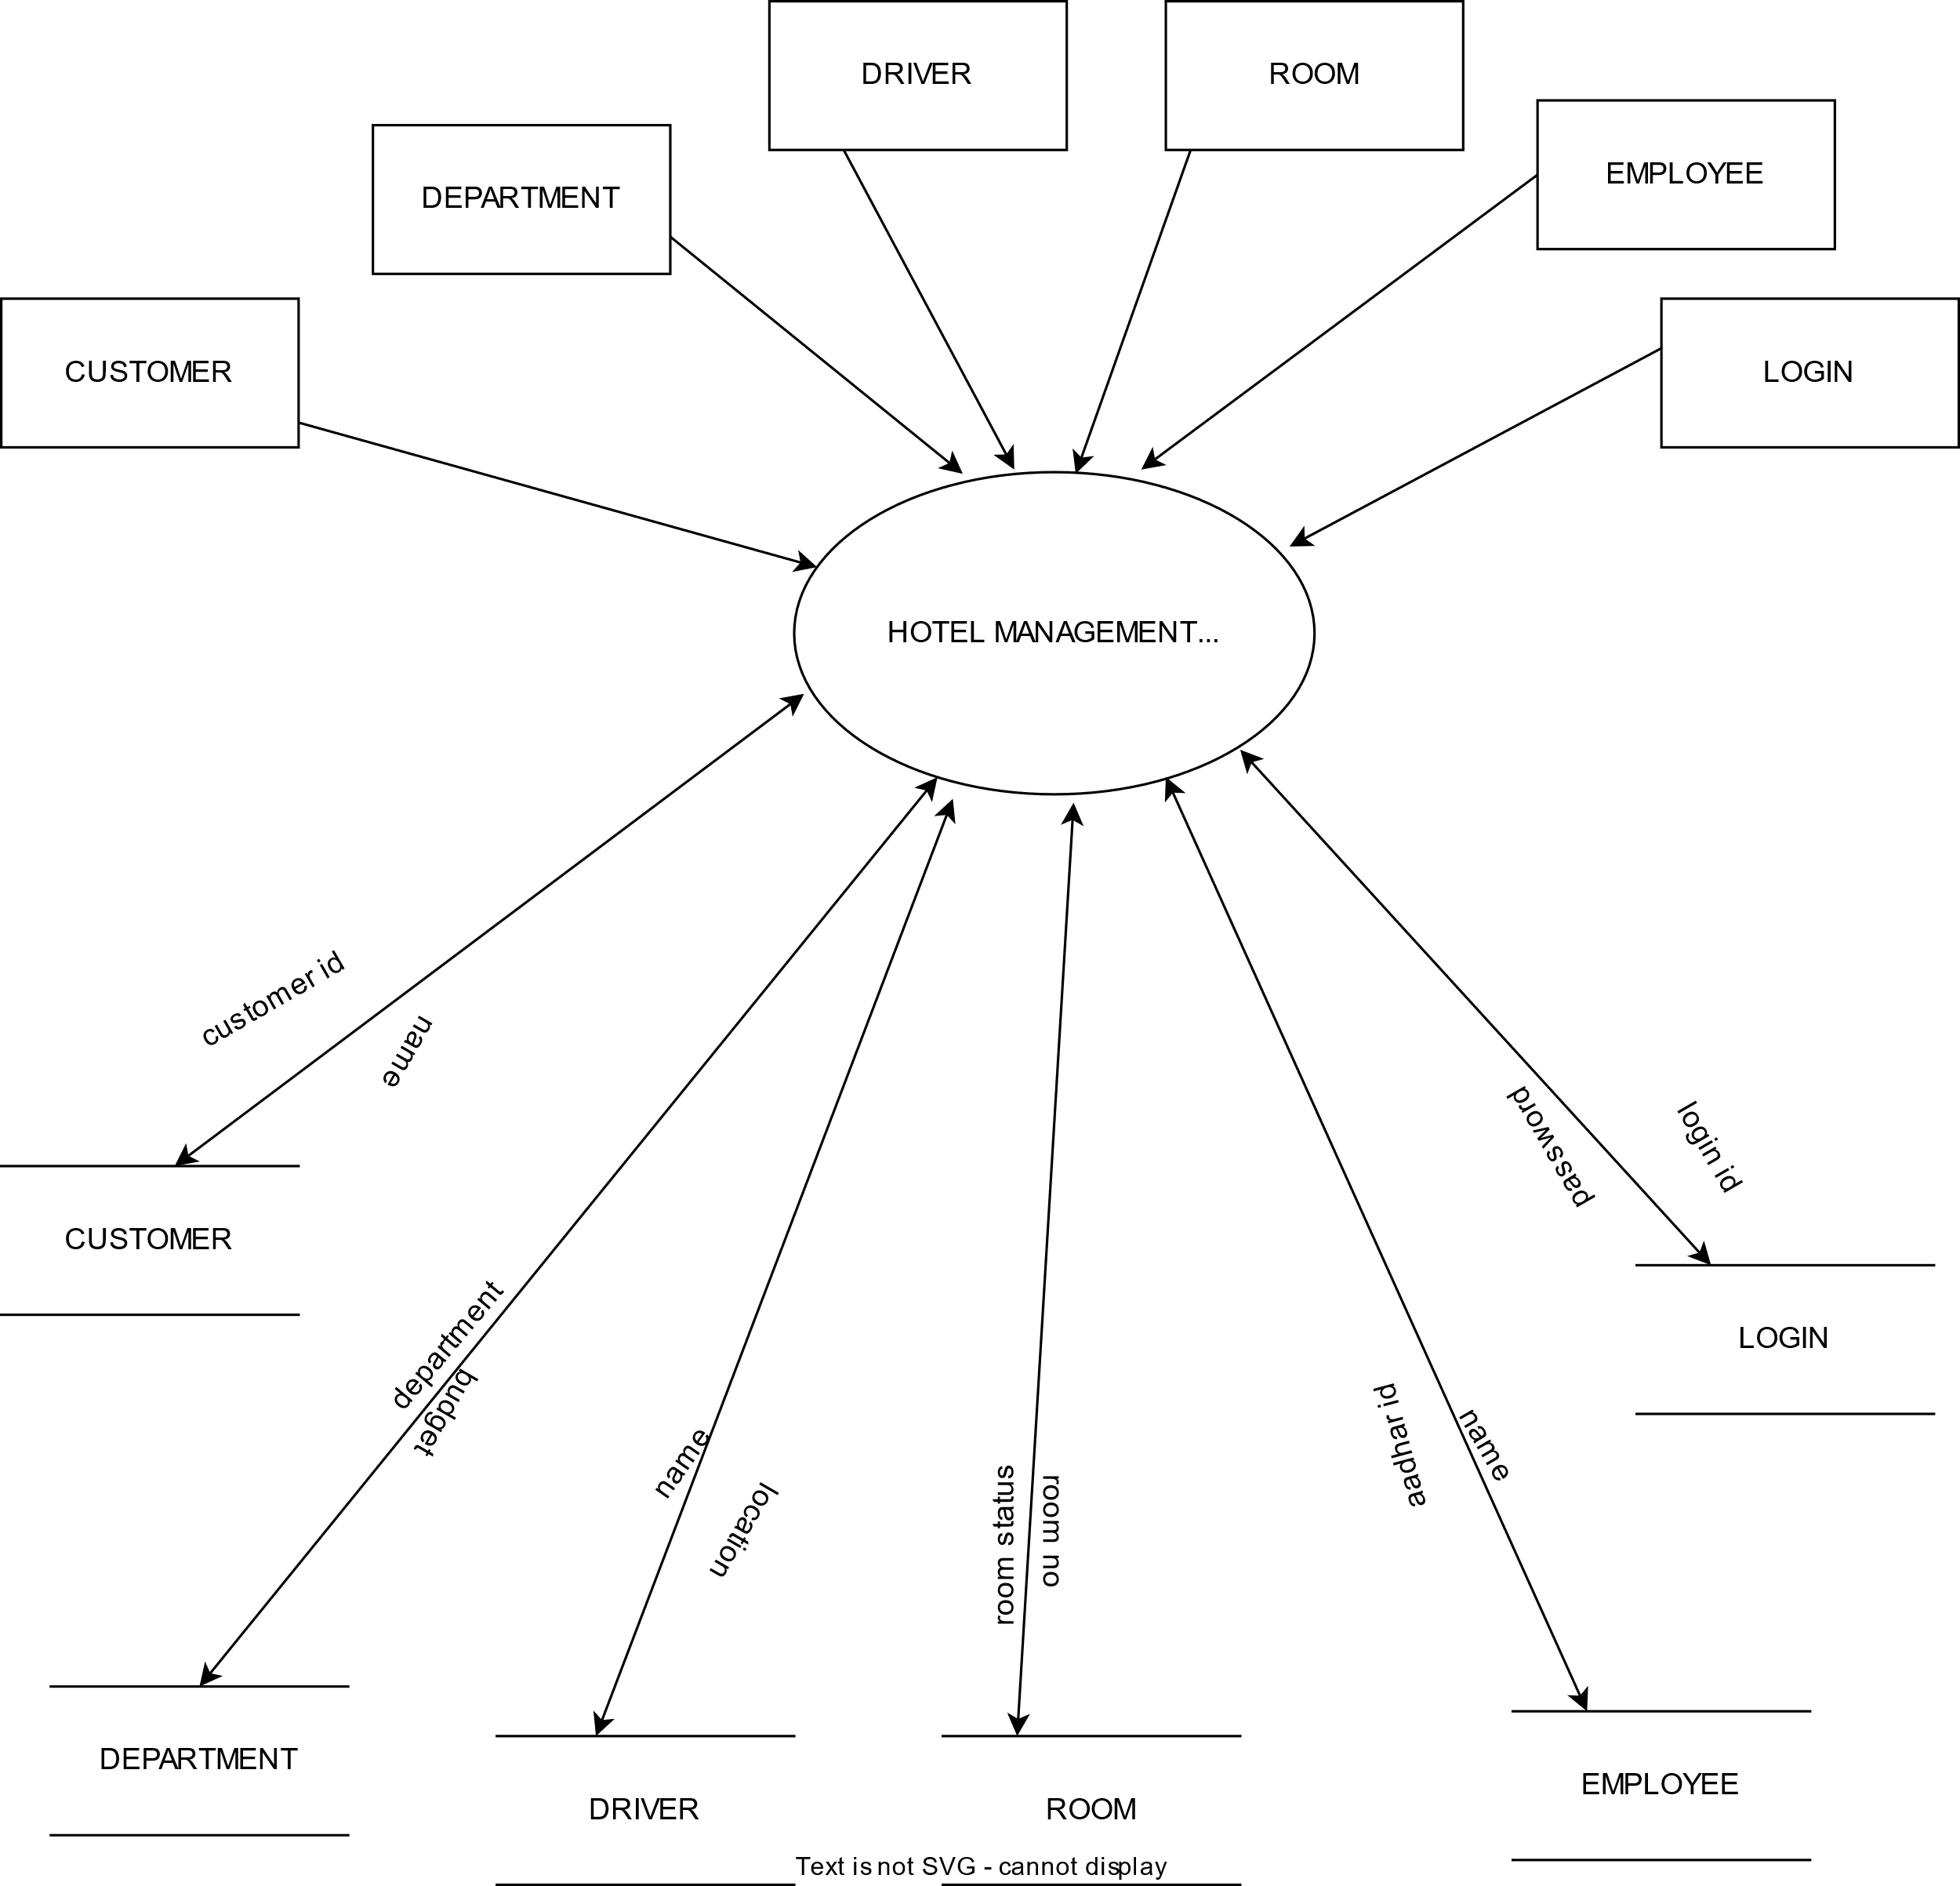

* **DFD Level 1**



**UML Diagram**

* **Use Case Diagram**

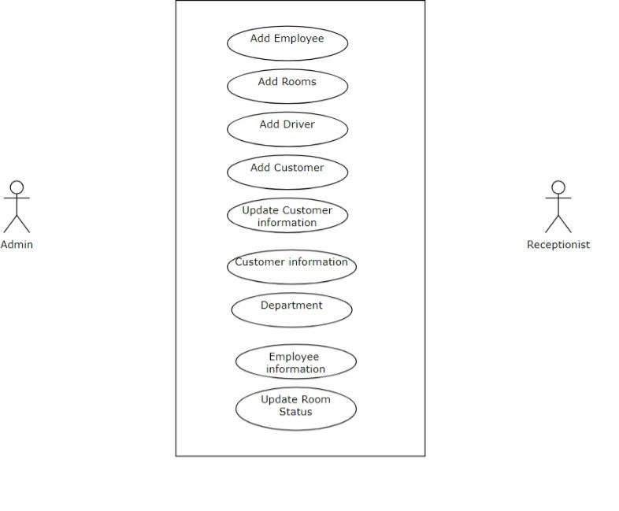

* **Class Diagram**

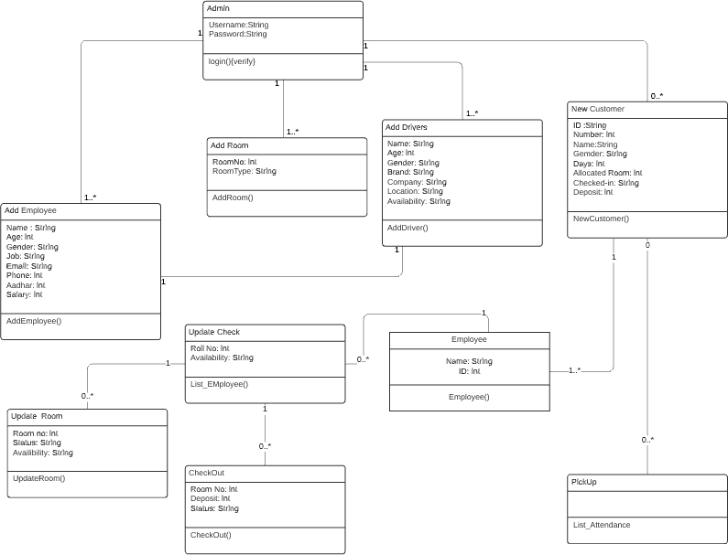

**Input Output Screens**

1. 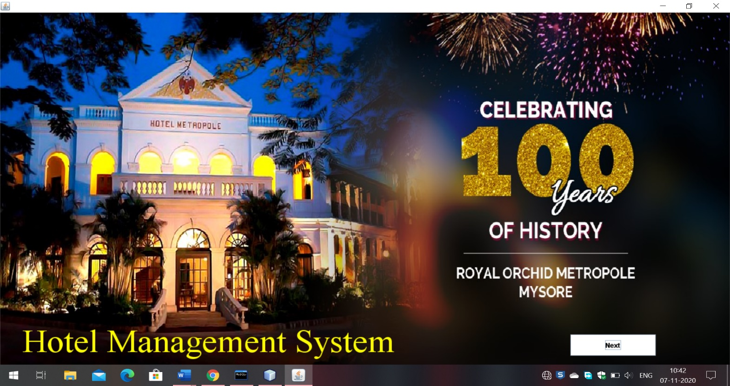Start Screen

2.Login Page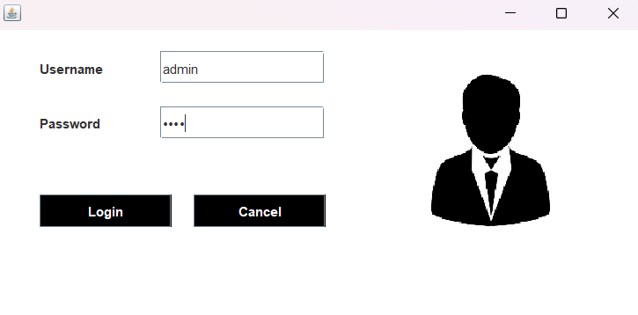

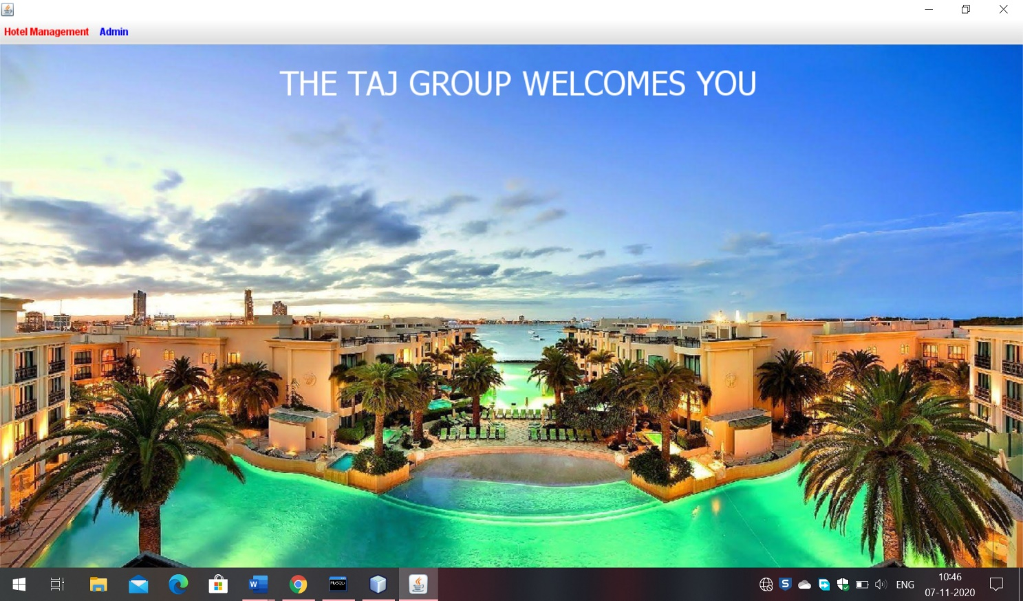3.DashBoard Page

4.Add Employee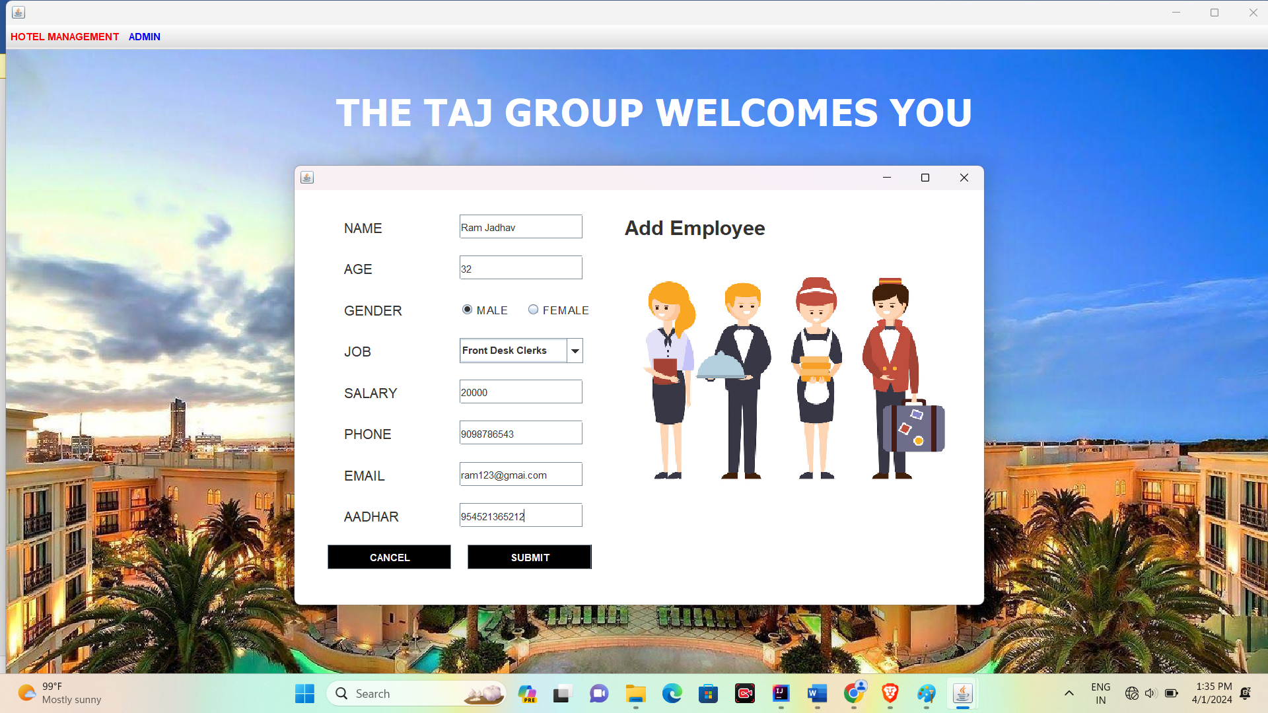

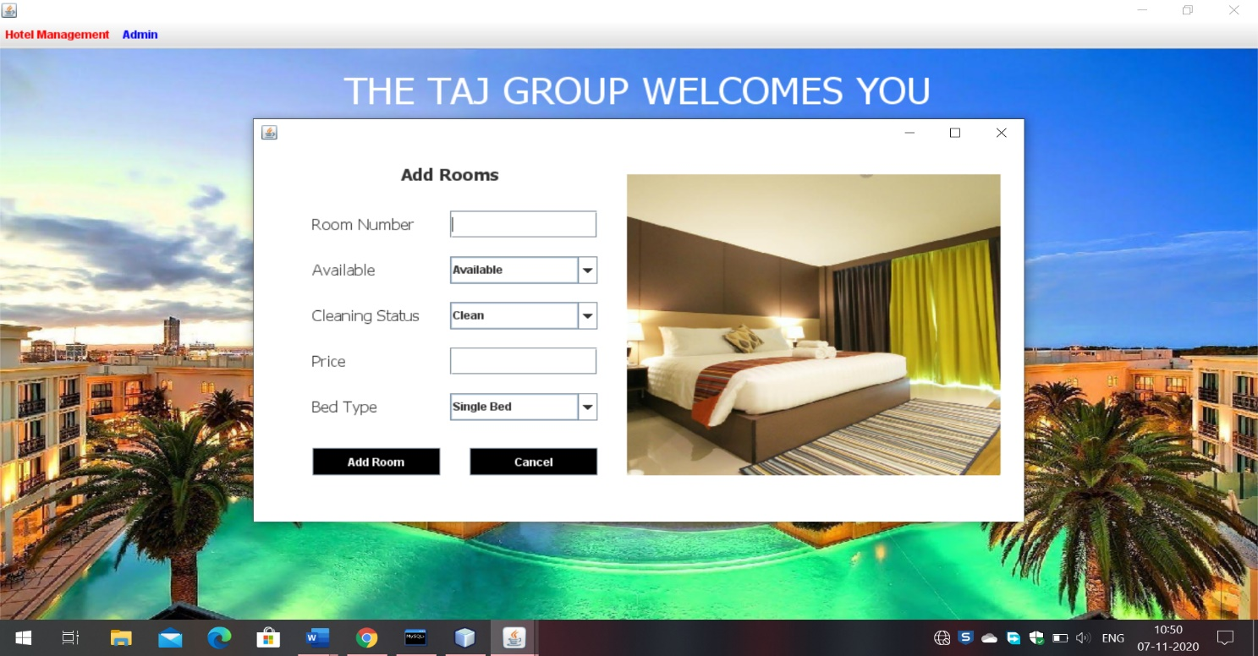5.Add Rooms

6.Add Driver

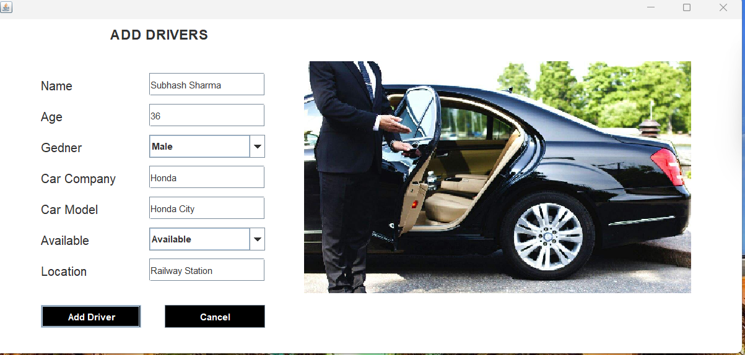

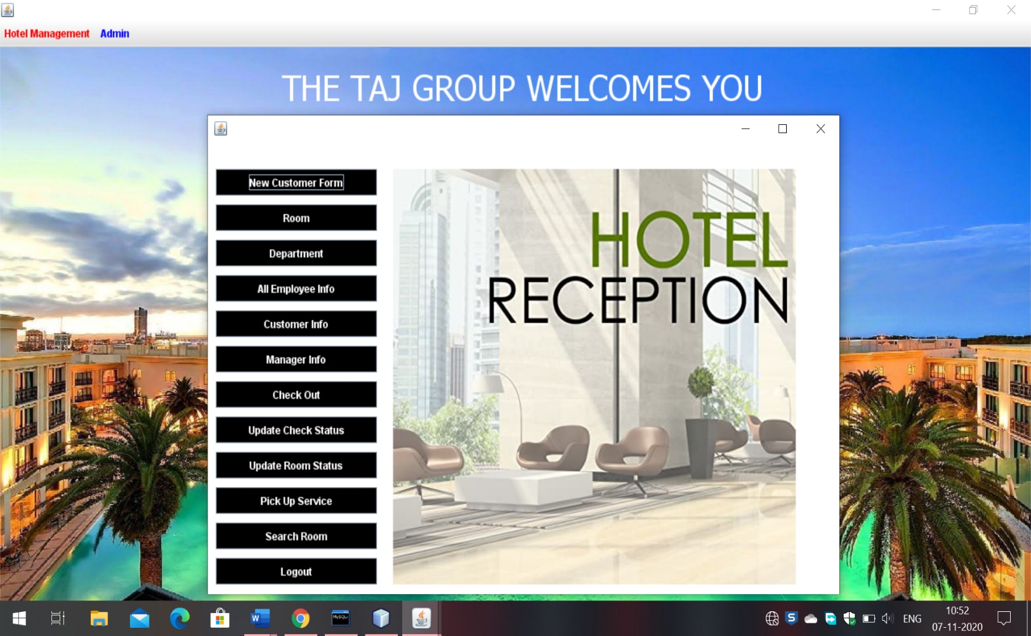7.Reception

8.Add new Customer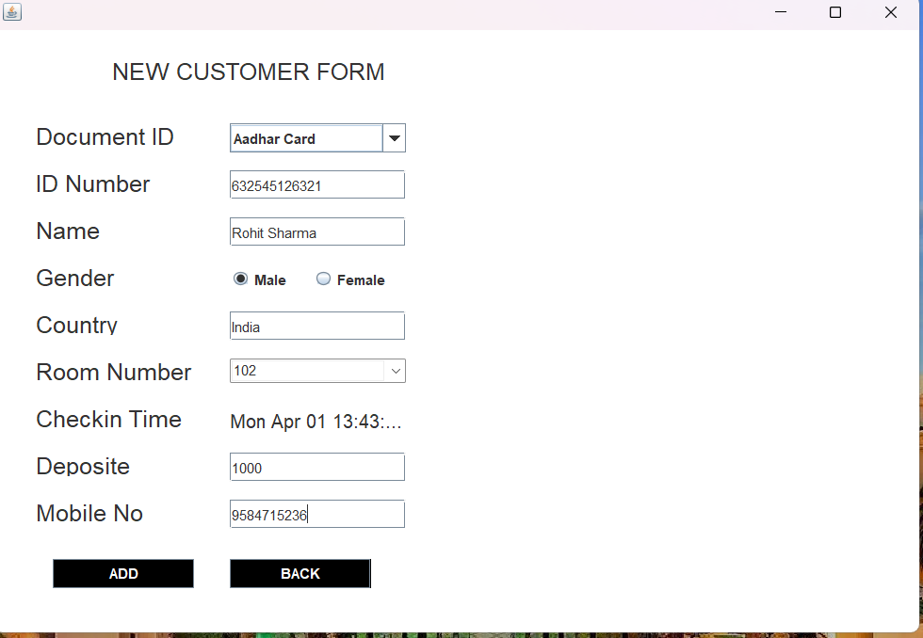

9.Room Details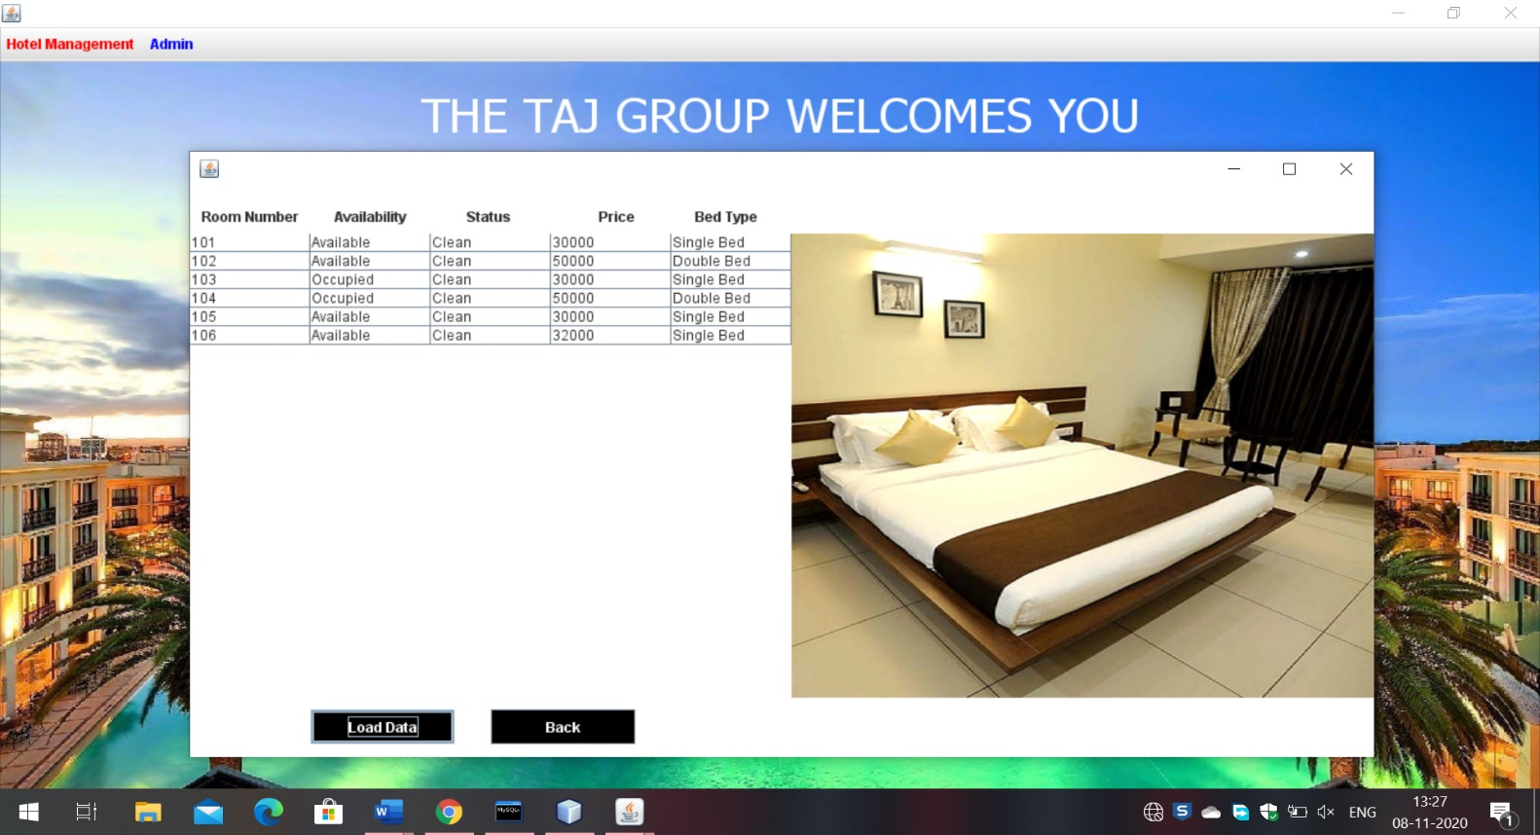

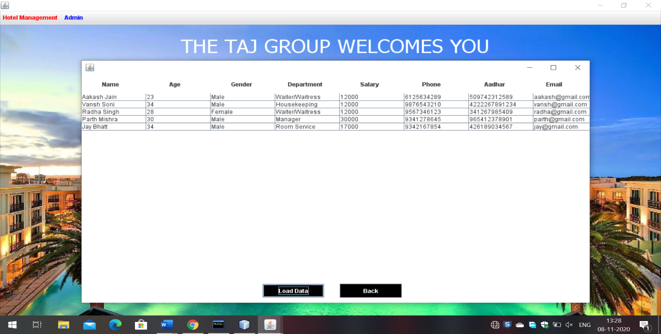10.Employee Details

11. Check In Details

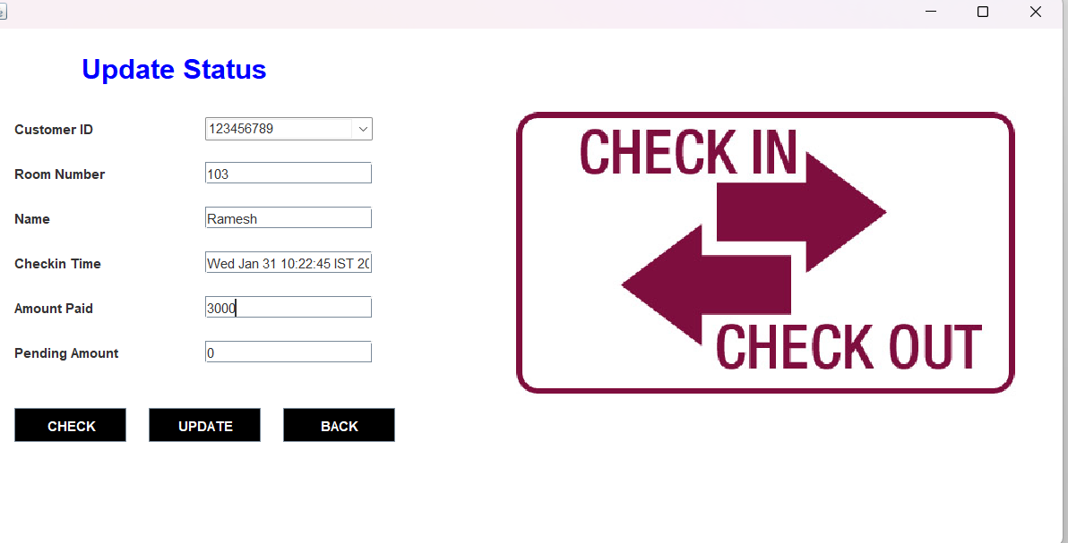

12. Check out

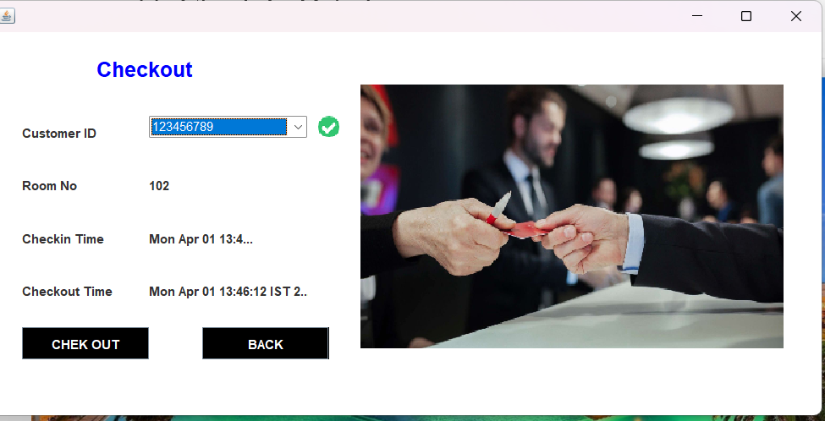

# **DRAWBACKS OF HOTEL MANAGEMENT SYSTEM**

* The booking process usually requires a customer identity, which the system cannot detect.
* It requires a database Connectivity
* It requires every entry manual ,i.e enter all data manually.

**Future Enhancements**

The world is changing rapidly and so is the meaning of the Hotel Management System. Today hotel management is not only confined to hotels but has gone deep into tourism, catering, clubs, etc making it a very paying and an exciting career option.

With the rapid growth of the hotel industry pushed forward by foreign and domestic tourism and business travels, the demand for well trained and quality personnel too has gone up high. India is one of the preferred tourist and travel destinations. Approx 4.4 million tourists visit our country every year. The growth of 20% has been recorded in the tourist and hospitality industry over a few years and more growth is expected in coming years. At present, there are about 200 millions of jobs available in the industry, out of which 20% of the job opportunities are in India.

The Hotel Management System has a lot of enhancement options. In future more features may be added category-wise. It may try to analyze the user behaviour and preferences and accordingly suggest. All concepts can be applied to make the Hotel Management System more efficient

**REFRENCES AND BIBLIOGRAPHY**

[**www.youtube.com**](http://www.youtube.com)

[**www.google.com**](http://www.google.com)

[**www.javatpoint.com**](http://www.javatpoint.com)

[**www.w3schools.com**](http://www.w3schools.com)

[**https://docs.oracle.com/en/java/javase**](https://docs.oracle.com/en/java/javase)

**mysql.com**

**Conclusion**

In this project I have tried my best to make user friendly software. This software can be handled by any person who has little bit of idea of computers. In this software I have tried to meet most of the requirements of the present hotel management system including maintaining details of customers, rooms, employees and drivers. I also keep provision to update the details of customers, rooms and employees. In my effort I have tried to make my software all the more user friendly but there may some features which I would like to include in my continuous attempts.